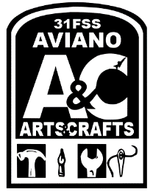  Balloon Liability Waiver  31FSS/FSWT  The Skills Development Center will always do its absolute best in providing you outstanding service.  (Outside balloon) I acknowledge that I have brought in balloons that were not purchased in the store and/or are being refilled. With that, I assume all liabilities. The Skills Development Center is not responsible for any damage and/or faults the balloon(s) may have. (Too thin/small to hold helium or any defects that prevent the Sales Clerk from blowing up the balloon)  (A&C product) I acknowledge that, when buying balloons The Skills Development Center is not responsible for any damage that happens to balloons after I leave the store.  High-Float: Y / N ( Additional Cost )  High-Float: is a product we offer that prolongs the life of balloons.  I understand the above  ___________________________Date: ________________ | Balloon Liability Waiver  31FSS/FSWT  The Skills Development Center will always do its absolute best in providing you outstanding service.  (Outside balloon) I acknowledge that I have brought in balloons that were not purchased in the store and/or are being refilled. With that, I assume all liabilities. The Skills Development Center is not responsible for any damage and/or faults the balloon(s) may have. (Too thin/small to hold helium or any defects that prevent the Sales Clerk from blowing up the balloon)  (A&C product) I acknowledge that, when buying balloons The Skills Development Center is not responsible for any damage that happens to balloons after I leave the store.  High-Float: Y / N ( Additional Cost )  High-Float: is a product we offer that prolongs the life of balloons.  I understand the above  ___________________________Date: ________________

